Practical 1 (**MAD**):

**Q.1: List Version of Android OS**

Android 1.0 - No specific code name

Android 1.1 - No specific code name

Android 1.5 Cupcake

Android 1.6 Donut

Android 2.0 Eclair

Android 2.2 Froyo

Android 2.3 Gingerbread

Android 3.0 Honeycomb

Android 4.0 Ice Cream Sandwich

Android 4.1 Jelly Bean

Android 4.4 KitKat

Android 5.0 Lollipop

Android 6.0 Marshmallow

Android 7.0 Nougat

Android 8.0 Oreo

Android 9 Pie

Android 10 - No specific code name

Android 11 - No specific code name

Android 12 - Snow Cone (unofficially referred to as "Snow Cone")

Android 13 - Android 13 Tiramisu

Android 14 Upside Down Cake

**Q.2: State Characteristics of Android OS**

1: Open Source:

Android is an open-source platform, allowing developers to access and modify the source code.

2: Customization:

Users can customize the appearance and behavior of their Android devices, including themes, widgets, and launchers.

3: Multitasking:

Android supports multitasking, enabling users to run multiple applications simultaneously.

4: Variety of Devices:

Android runs on a diverse range of devices, including smartphones, tablets, smartwatches, TVs, and more.

5: Google Play Store:

Android devices typically come with access to the Google Play Store, offering a vast repository of applications.

6: Security Features:

Android incorporates various security features, such as app sandboxing, permissions, and encryption, to protect user data.

7: Regular Updates:

Google releases regular updates to the Android OS, providing new features, improvements, and security patches.

8: Notification System:

Android features a comprehensive notification system that provides information and alerts from various applications.

9: Integration with Google Services:

Android seamlessly integrates with various Google services, including Gmail, Google Drive, Google Maps, and more.

10: Voice Assistance:

Android devices often come with Google Assistant, a voice-activated virtual assistant for performing tasks and answering queries.

11: Connectivity Options:

Android supports a wide range of connectivity options, including Wi-Fi, Bluetooth, NFC, and mobile data.

File Management:

Users have access to a file system, allowing them to manage and organize files on their devices.

12: Widgets:

Android supports home screen widgets, providing quick access to information and functions without opening the full app.

13: Fragmentation:

Android's open nature has led to device fragmentation, where different devices may run different versions of the OS.

14: Development Flexibility:

Android provides flexibility for app development, supporting multiple programming languages and development tools.

15: Emphasis on Google Play Protect:

Google Play Protect is a built-in security feature that scans and verifies apps on the device to prevent malware.

**Q.3: Draw the Architectural Diagram of Android OS:**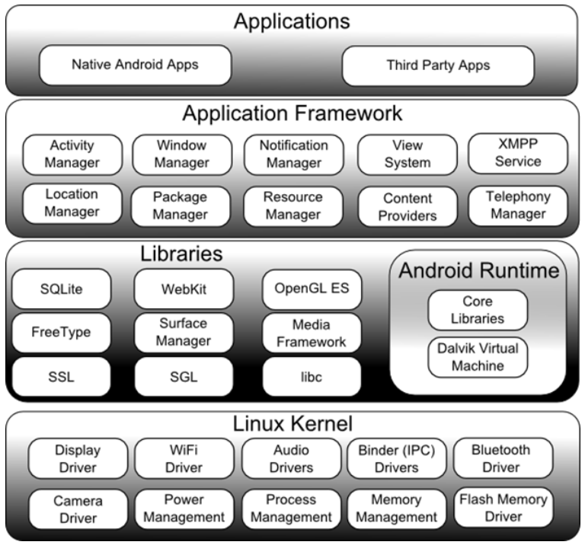

**Q.4: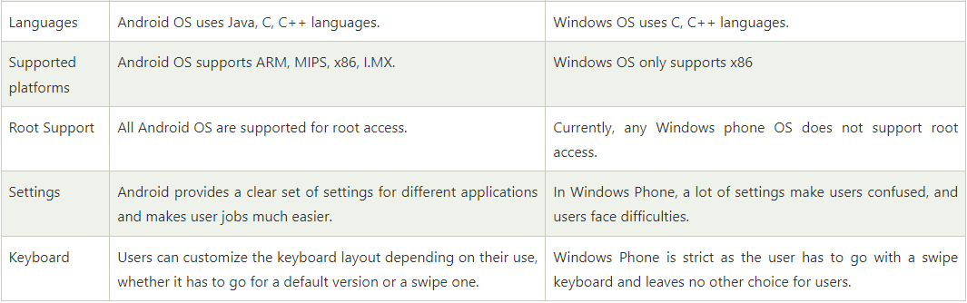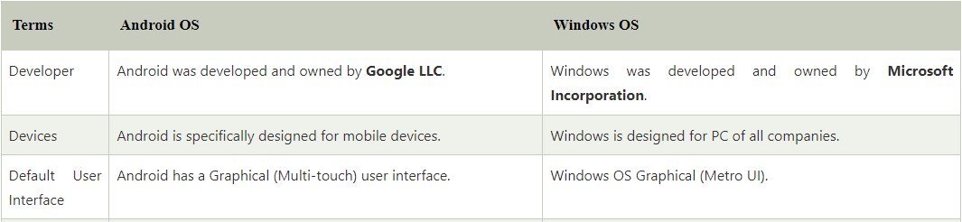 Differentiate between Windows OS and Android OS**